Research Project 4

1. Build your approved survey in StatCrunch.
2. Go to [www.statcrunch.com](http://www.statcrunch.com).
3. Click on “creating a new survey” to create a survey.

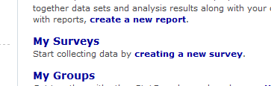

1. Name your survey with the last names of all group members.
2. Click “open for responses”.
   1. You can pick a picture if you want!
3. Hit submit.

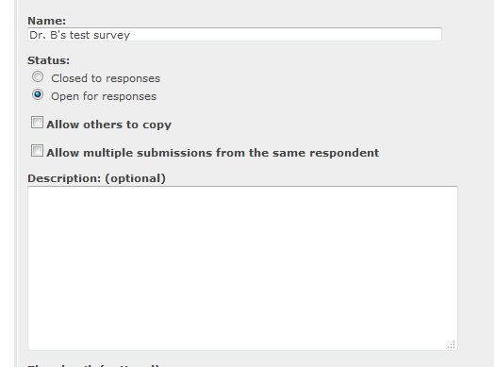

1. After you hit submit, you will see add question options.

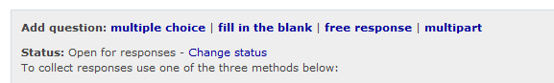

1. Most questions will be multiple choice. Click on multiple choice.

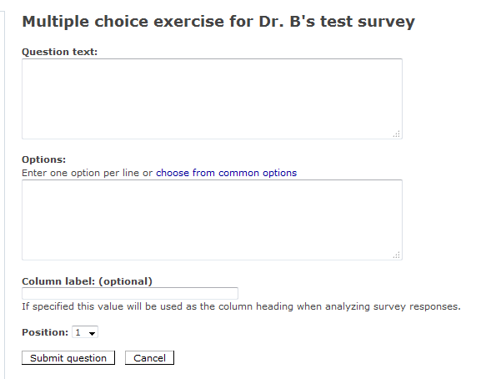

1. Create questions one at a time.

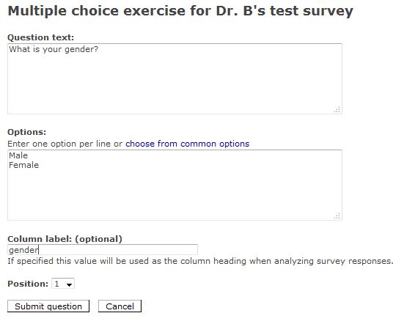

1. Once you’ve added several questions, you’ll see them at the bottom.

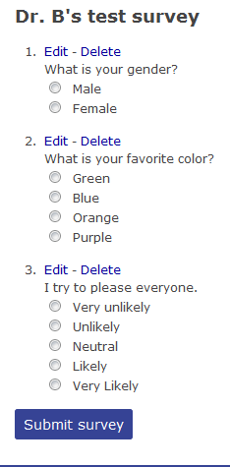

1. Once you are done, turn in the email link code on blackboard. (i.e. cut and paste into the submission on blackboard).

